Instructions to convert an image for GCBasic SSD1289 driver:
- Open the ImageConverter 565 v2.3 program
- Open the Image you want to convert
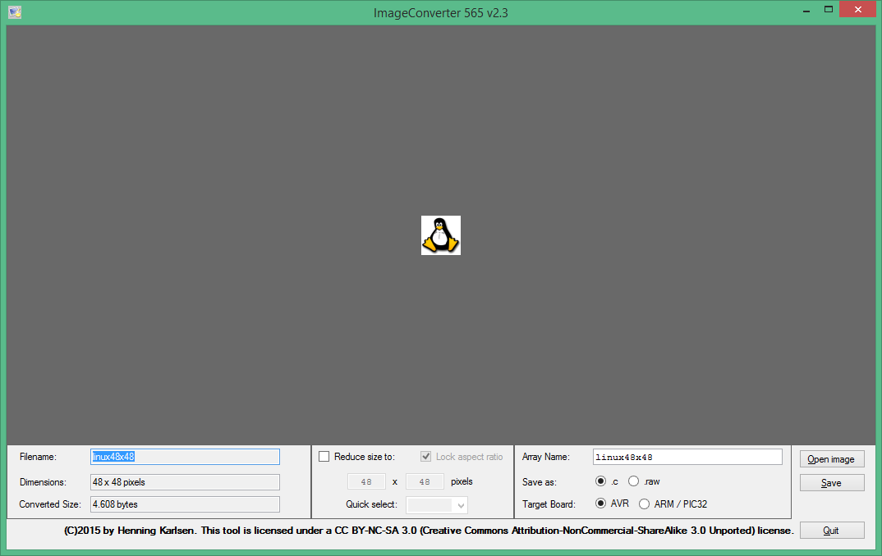
- Make sure to check out how many pixels your image has. For example in the picture above the image has 48x48 pixels
- You have to save your image as : .c and Target Board : AVR
- Press save and name it as Linux.c .
- From the edit menu use the replace tool and replace the // with ‘ or ;
- if you followed the instructions correctly you will be able to see the following file
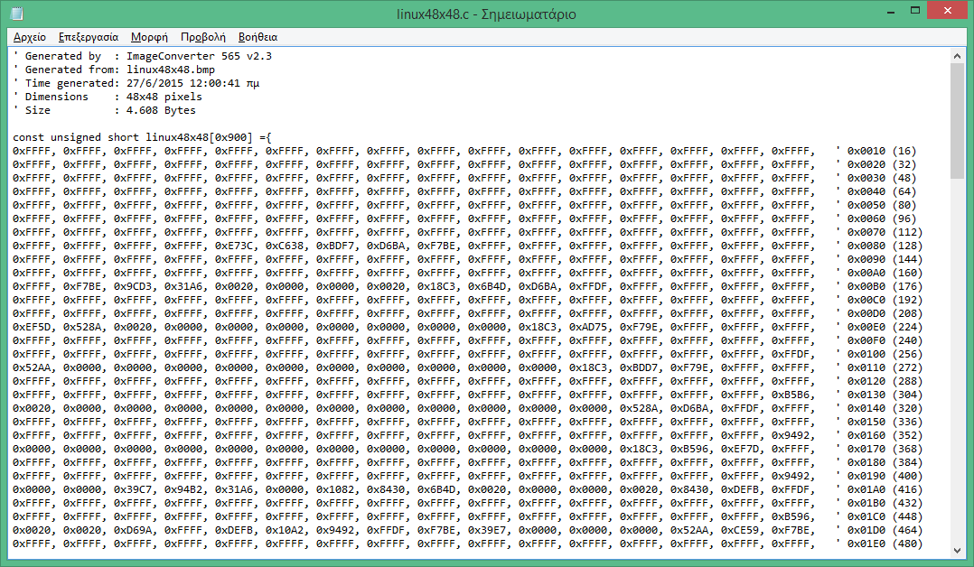
- Copy all of the data bellow the bracket
- On SynWrite program create a blank page and name it bmp.h
- On the top of the page write the command #define Image1 @TableImage1
- Create the table : Table TableImage1 as Word
- Make sure your first two entries are the dimentions of your image written in hexadecimal numbers.(In the picture below it is 0x0030 , 0x0030 which is 48x48 in decimal system)
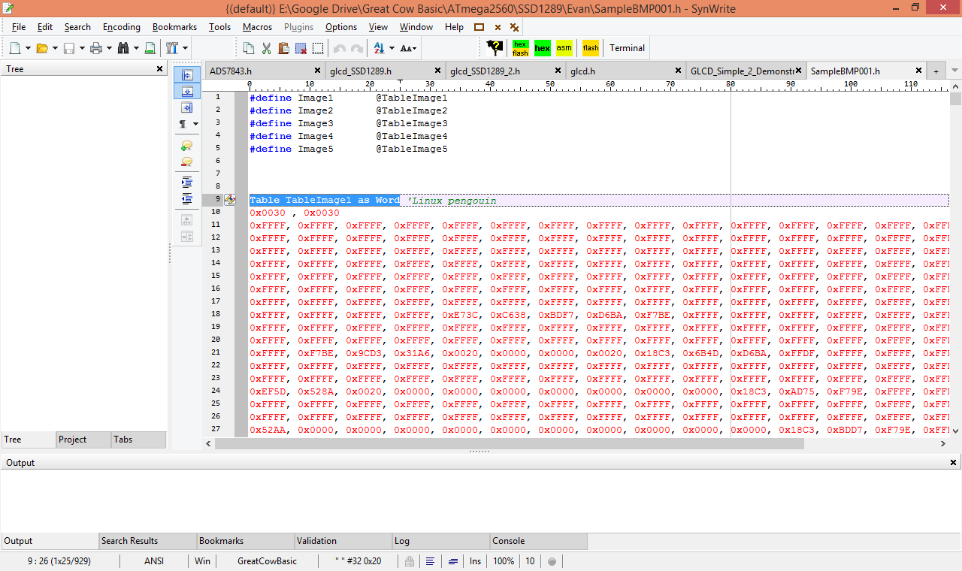
- Paste the data from the filename.c and close the table
- Save the file

